**Windows Version**

/*

10/22/2017

Nabir Migadde/Melanie Sou

1648223/1606508

CISP 360 - M/W 1:30pm - 2:50pm

Spring 2017

Assignment #8 Rectangle Area

Calculate an area of a rectangle

*/

#include <iostream>

using namespace std;

//Function Prototypes

double getLength (double &);

double getWidth (double &);

double getArea (double &, double &, double &);

void displayData (double , double , double);

//Rectangle Area Calculator

int main(){

//Initialization of Variables

double length;

double width;

double area;

getLength(length); //Get Length of Rectangle

getWidth(width); //Get Width of Rectangle

getArea(length, width, area); //Calculate Area of Rectangle

displayData(length, width, area); //Show Results to User

return 0;

}

//getWidth Function

double getLength (double &len)

{

cout << "Enter the length: "; //Input Length

cin >> len;

return len;

}

//getLength Function

double getWidth (double &wid)

{

cout << "Enter the width: "; //Input Width

cin >> wid;

return wid;

}

//getArea Function

double getArea (double &len, double &wid, double &areas)

{

areas = len * wid; //Multiply Length by Width

return areas;

}

//displayData Function

void displayData (double len, double wid, double areas)

{

//Display Results and Calculations to Console

cout << endl;

cout << "Rectangle Data" << endl;

cout << "--------------" << endl;

cout << "Length: " << len << endl;

cout << "Width: " << wid << endl;

cout << "Area: " << areas << endl;

}

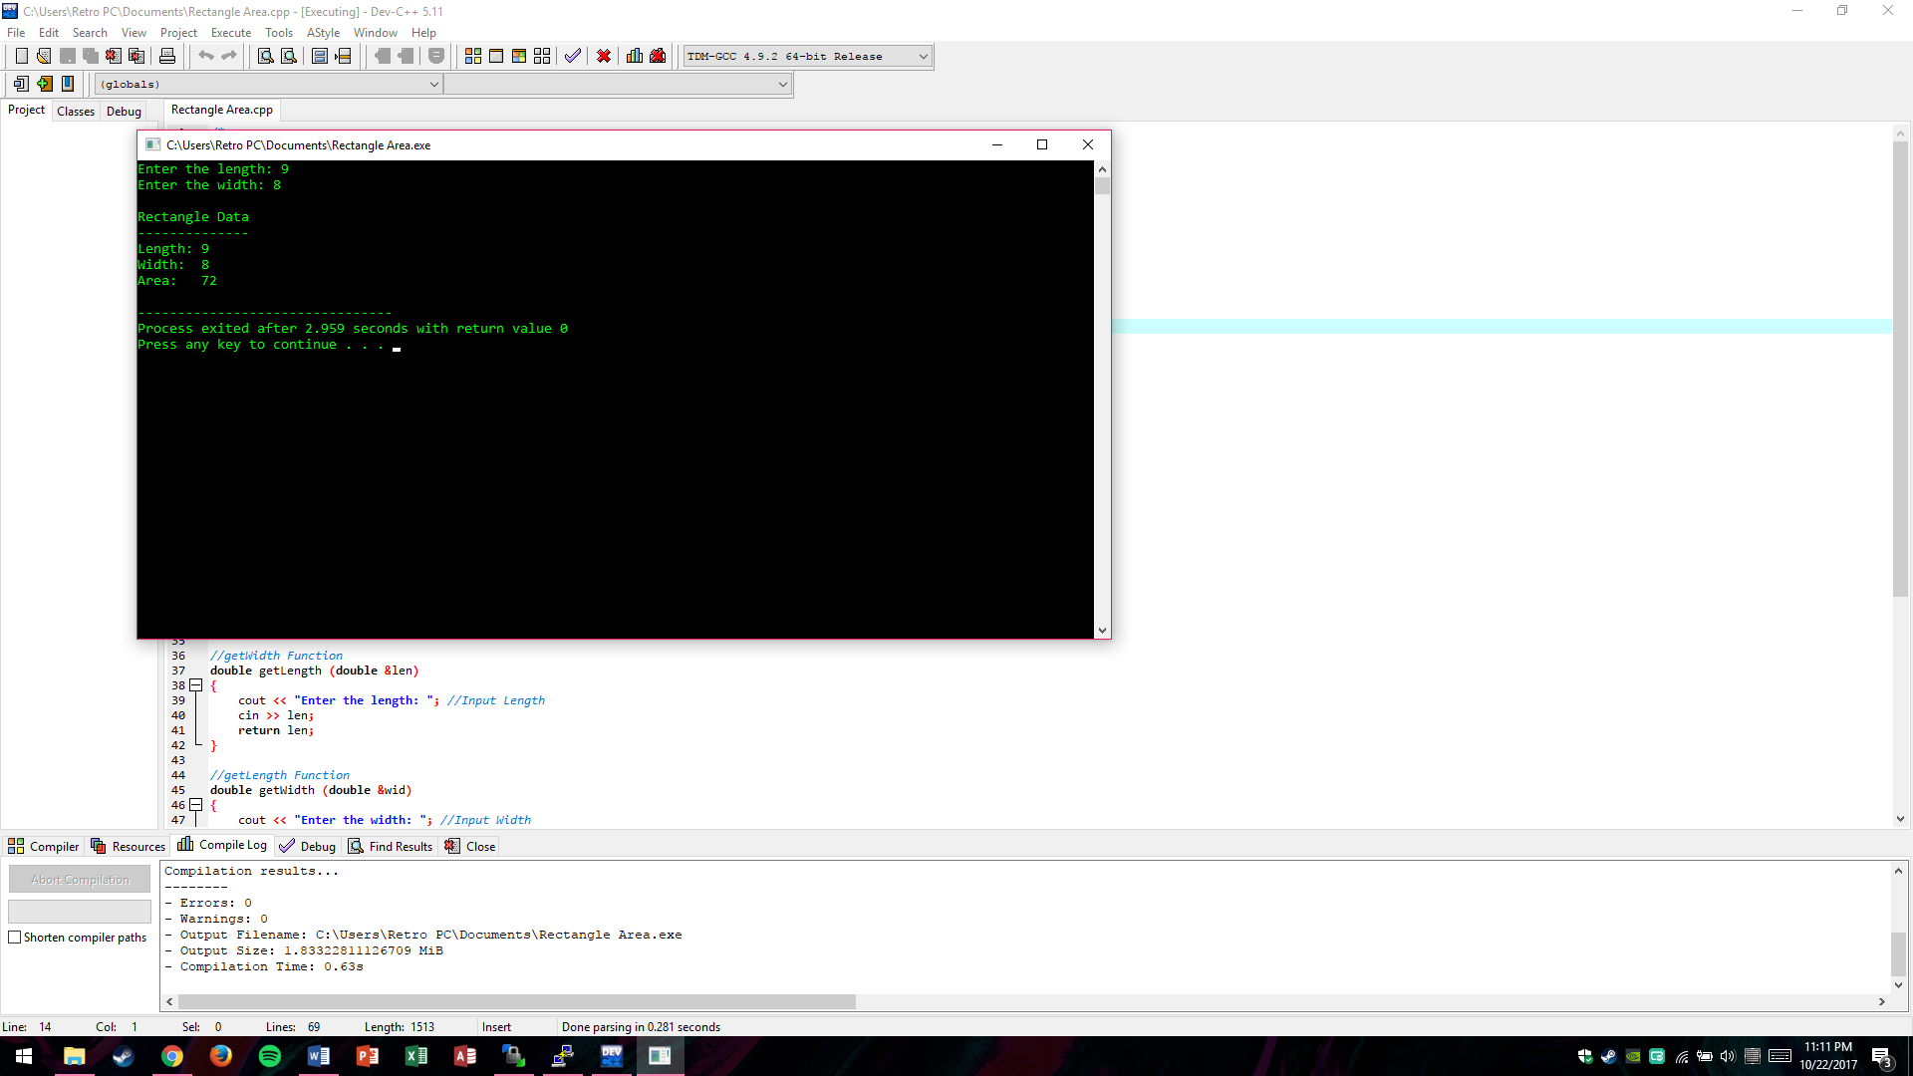

**Linux Version**

/*

10/22/2017

Nabir Migadde/Melanie Sou

1648223/1606508

CISP 360 - M/W 1:30pm - 2:50pm

Spring 2017

Assignment #8 Rectangle Area

Calculate an area of a rectangle

*/

#include <iostream>

using namespace std;

//Function Prototypes

double getLength (double &);

double getWidth (double &);

double getArea (double &, double &, double &);

void displayData (double , double , double);

//Rectangle Area Calculator

int main(){

//Initialization of Variables

double length;

double width;

double area;

getLength(length); //Get Length of Rectangle

getWidth(width); //Get Width of Rectangle

getArea(length, width, area); //Calculate Area of Rectangle

displayData(length, width, area); //Show Results to User

return 0;

}

//getWidth Function

double getLength (double &len)

{

cout << "Enter the length: "; //Input Length

cin >> len;

return len;

}

//getLength Function

double getWidth (double &wid)

{

cout << "Enter the width: "; //Input Width

cin >> wid;

return wid;

}

//getArea Function

double getArea (double &len, double &wid, double &areas)

{

areas = len * wid; //Multiply Length by Width

return areas;

}

//displayData Function

void displayData (double len, double wid, double areas)

{

//Display Results and Calculations to Console

cout << endl;

cout << "Rectangle Data" << endl;

cout << "--------------" << endl;

cout << "Length: " << len << endl;

cout << "Width: " << wid << endl;

cout << "Area: " << areas << endl;

}

